Western Treatment Plant GIS Mapping Lesson: Year 7&8

A GIS map uses data organised in layers of information. By turning layers on and off, data and information is revealed, and patterns and relationships can be analysed.

Introduction
In this task, students develop their GIS mapping and spatial skills. They consider the location of the Western Treatment Plant (WTP) and their relationship to the site and treatment of sewage.
When exploring the research question ‘How can we manage Melbourne’s water sustainably as a valuable renewable resource?’ students will need to investigate the treatment of wastewater.

Resources
- Students will need a computer or a device each or in pairs
- Access to the internet to access this link - Melbourne’s waterways and catchments

Learning outcomes
- Navigate a GIS map including turning layers on and off and using a measuring tool
- Analyse a GIS map to develop explanations and draw conclusions
- Identify the catchment they live or go to school in
- Make connections between their home or school and the WTP
- Explain the spatial distribution of the sewerage network

*Note: this lesson can be completed before or after your visit to the WTP

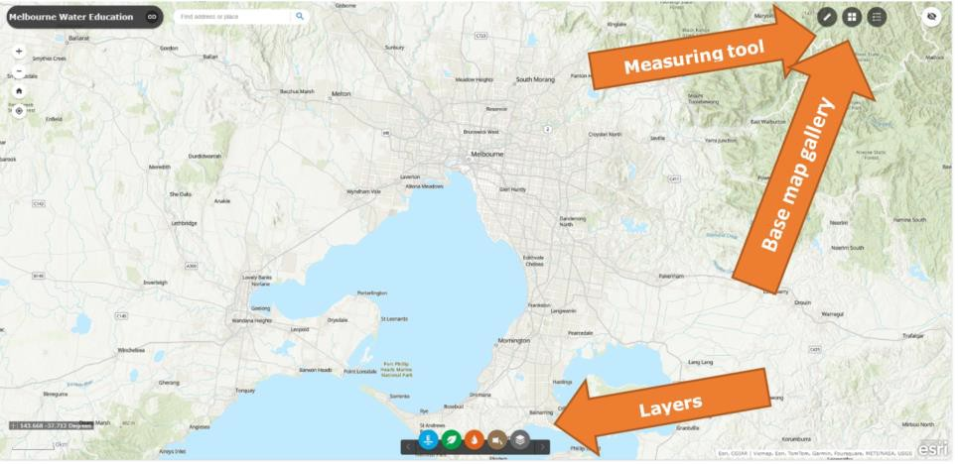
Instructions
Step 1: Navigate to an interactive GIS map of
Melbourne’s waterways and catchments.

Step 2: Explore the map. Click layers on and off. Look at the measuring tool and different base maps

Step 3: Click ‘Catchment, Rivers, Retarding Basins and Wetlands’. Click the layer ‘Catchments - Major River Basins.

Ask students:
- What is a catchment?
Answer: A catchment is an area of land where water (from precipitation) is collected by the natural landscape. The water then flows or drains into rivers, creeks, dams, lakes or into a groundwater system
- Which catchment is your home or school located in? (Hint: the catchment is named after the major river running through it)
Answer: will vary

Step 4: Click the layer off again

Step 5: Click the ‘Sewers and Sewage’ icon. Click ‘Western Treatment Plant Carrier and Mains’.

Ask students:
- What is this showing?
Answer: This shows a network of pipes at the WTP.

Step 6: Click the ‘Sewers and Sewage’ icon. Click ‘Sewerage Network Main Pipelines’.

Ask students:
- What do you notice about the sewerage network?
Answer: The main pipelines are networked and connected.
- Explain the spatial distribution of the sewerage network.
Answer: The main pipelines are located across the city and there is more of a network of pipes closer to the city and the south-east

Step 7: Change the base map to ‘imagery’.

Ask students:
- Describe the relationship between populated areas and the sewerage network.
Answer: The main pipes network is located over built up areas; the WTP is located in an area that is not built up while the ETP is surrounded by housing.

Step 8: Zoom in to the Western Treatment Plant to get a better view. For best results, the scale should show 2 km or 3 km. Locate Pond 1 on the map.

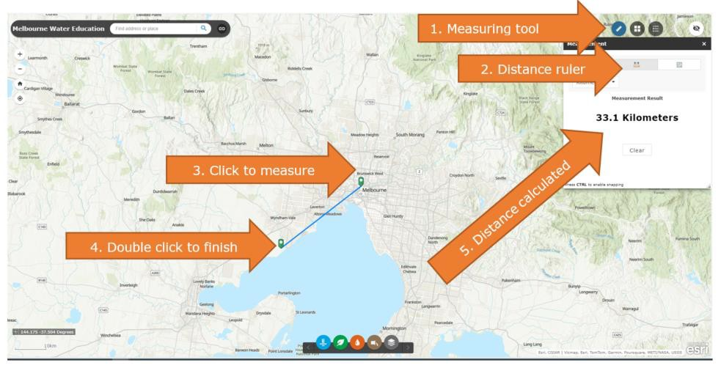
Ask students:
- Estimate the distance between the end of the sewerage network and pond 1. Now use the measuring tool to calculate the actual distance.
Answer: The distance is approximately 5.3km
- How far does your poo travel? Make a prediction and then check by using the measuring tool – from your house to the WTP if you live in the city or the West, or the ETP if you live in the East (you can do it ‘as the crow flies’ (straight line distance) or challenge yourself to follow the sewerage network – make sure you turn that layer on).
Answer: Will vary
Extension activity
Step 1: Turn on the layers for the Eastern Treatment Plant (ETP).

Ask students:
- What are the similarities and differences between the ETP and the WTP?
Answer: The WTP is a much larger site when compared to the ETP. The WTP has more ponds and is surrounded by more open space.

Step 2: Turn on the layer for the Water Supply Main Pipelines.

Ask students:
- Is there a correlation between those and the sewerage network? Explain your answer.
Answer: There is little correlation between the two. The water supply main pipelines extend into the east and north-east of the city. The water supply pipelines are a different network of pipes to the sewage pipes.
- Explain how this network of pipes providing water and removing sewage are important for sustainability and the liveablility of Melbourne.
Answer: Answers will vary but could include a response that outlines the importance of providing safe drinking and removal of wastewater.

Victorian Curriculum Geography Year 7&8
Geographical Knowledge and Understanding: VC2HG8K01, VC2HG8K03
Geographical Skills: VC2HG8S02, VC2HG8S03, VC2HG8S04

